Northcoast Preparatory and Performing Arts Academy

Expanded Learning Opportunity Program Handbook
2025-2026

Purpose:
The purpose of the Expanded Learning Opportunity Program (ELOP) at Northcoast Preparatory and Performing Arts Academy (NPA) is to provide academic support, enrichment and connections for students beyond the regular school day.
Expanded learning means after school, summer, or intersession learning programs that focus on developing the academic, social, emotional, and physical needs and interests of our students through hands-on, engaging learning experiences.

Yearly Calendar:
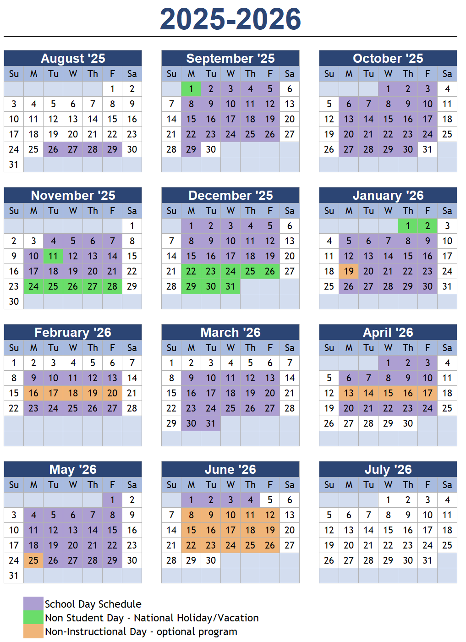

Hours of Operation:

Sign-in/Sign-Out Procedures:
An authorized individual listed on the emergency contact list must sign in or out all students out each day. Photo ID’s will be checked when a new staff or authorized individual is facilitating the pick-up of students. FOR YOUR CHILD’S SAFETY, THESE RULES ARE STRICTLY ENFORCED.

Nutrition Program:
A healthy snack will be provided to all students each day of the program. On Non-Instructional days lunch will be provided in addition to morning and afternoon snacks.

Academic Support Time:
Approximately 40 minutes will be set aside each day for students to complete assigned homework. This time is a priority above all other activities in our Expanded Learning Programs. Academic support offers a quiet, safe environment for students to complete their homework in a timely manner. This is an independent study opportunity with support from ELOP staff. Tutoring is offered and is based on teacher availability.

Enrichment Activities:
Our ELOP staff focus on making connections to the regular school day curriculum, introducing students to new ideas, and developing the talents and interests of each student. Enrichment activities encourage exploration and learning in creative ways. The activities are based on students’ needs and interests. Activities include, but are not limited to, STEM, arts and theater, healthy living, crafts, music, career awareness, technology, and community service learning.

Recreation:
Physical movement is an important part of our students’ day. There will be time each day for movement, be it free play, games or team building activities.

Behavior Management Procedures:
All ELOP personnel treat students in a fair and impartial manner by modeling the appropriate behaviors of mentors and teachers when leading activities with students. “Positive discipline” protocols are used to redirect students to avoid disruptive behavior and increase responsible choices and student cooperation.
Our programming provides simple, clearly defined classroom agreements that align with the regular day but are flexible and accessible to ensure inclusion for all students participating in the program. ELOP staff monitor student behavior to ensure that all children are safe, treated with respect, and valued for their individuality.

Professional Development Closure Days:
All ELO Programs are entitled to three Professional Development days per school year. Parents will be given a minimum of two weeks notice before any site closures.

Waitlist Policy:
If the number of students wishing to participate in the program exceeds program capability, students shall be selected for enrollment based on the following guidelines:
1. First priority for enrollment shall be given to unduplicated students, which include, homeless and foster youth, English language learners, and economically disadvantaged students. The district is not required to disenroll a current student to secure the enrollment of a student who has priority for enrollment.
2. Second priority for enrollment shall be given to students selected on a “needs basis”.
3. All remaining students shall be placed on a waitlist that will be established to accommodate additional students, if space becomes available.
It is a requirement of the ELO Program to ensure that no individual program exceeds a student to staff ratio of 20:1. Administration will work with ELOP staff and student attendance documents to ensure that this requirement is fulfilled.

Staffing Emergency Procedure:
It will be the intention of NPA to plan for staffing its ELO programs for a given year. Emergency situations may not be predicted and will require quick communication with all impacted families. In the event that there is an emergency staffing shortage leading to an ELO program, it will be the responsibility of the administration to work to secure staffing. If this is not successful, it will be necessary for the Board of Directors to meet and pass an emergency resolution to cancel or postpone the ELO program.

